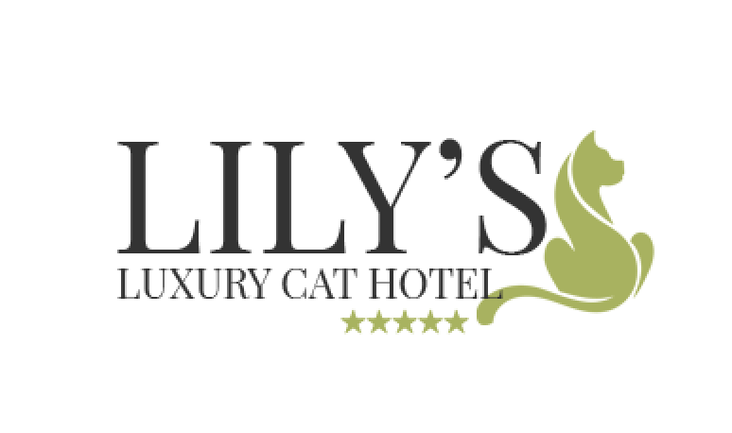

**Lily’s Retreat Registration Form**

As a condition of our licence and in the best interest of your cat, we are obliged to keep a register of all cats on our premises which must include all of the information requested on this form.  It is vital that you complete the form **in full** for each cat staying with us. Please indicate where anything is not applicable so we know you have considered the matter.

**Please ensure you hand us the form, along with up to date vaccination records, when you bring your cat to us.**

It is particularly important that you advise us of the action we should take in the unlikely event of an emergency, serious illness or injury to your cat.  Veterinary fees can run into thousands of pounds and not all cats are insured, so please provide as much information as possible about what we should do in such a situation.

Wherever possible we will contact you or your nominated local contact immediately, but there may be occasions when we are unable to reach you. If so, and it is obvious that urgent veterinary attention is required, we will instruct our vet on your behalf unless you have previously advised us otherwise. Our vets are:

**The Wheelhouse Veterinary Centre, Chalfont St Giles**

**Straid Veterinary Clinic, Beaconsfield**

Please note that if we have to instruct a vet on your behalf you will be liable for all costs incurred and **MUST** sign the form overleaf to confirm you agree to this. If you choose not to authorise us or your vet to proceed with emergency medical care in your absence, it is possible that your cat will not receive the treatment it needs and this could result in the death of your pet. If you choose to decline to pre-authorise vet charges, by signing this form, you agree to release us from liability for the death of your pet resulting from its failure to receive timely medical assistance. We may also decide that we are unable to look after your cat for you. We strongly advise that you take out insurance to cover veterinary fees.

**GDPR Notice**

Our legal basis for collecting and processing your personal data is that it is necessary in order for us to comply with our obligation to conform with the Government’s licencing conditions for Animal Boarding Establishments.

In addition, we need to collect and process your personal data in order to properly care for your pet in an emergency situation.

In connection with these obligations we may, from time to time, need to share your personal data with Government agencies, veterinary practices, insurance companies or other third parties in the interests of caring for your pet on your behalf.

By signing this form, you consent to us sharing your personal data with these third parties.

If you have any further questions about the way in which your data is managed, please write to us.

**LILY’S RETREAT REGISTRATION FORM**

|  |  |  |  |
| --- | --- | --- | --- |
| NAME OF OWNER |  | | |
| ADDRESS |  | | |
| E-MAIL ADDRESS |  | | |
| HOME PHONE |  | | |
| MOBILE PHONE |  | | |
| LOCAL EMERGENCY CONTACT IN YOUR ABSENCE | Name:  Address:  Phone number:  Email address: | | |
| NAME OF CAT(S) | Cat 1 | Cat 2 | Cat 3 |
| DATE OF BIRTH |  |  |  |
| SEX |  |  |  |
| NEUTERED? YES/NO |  |  |  |
| BREED |  |  |  |
| COLOUR |  |  |  |
| NB – If more than one cat is staying with us please note any distinguishing features or bring a photograph so we can easily identify each cat. | | | |
| VET PRACTICE NAME AND CONTACT TEL NO |  | | |
| PREFERRED VET  (IF APPLICABLE) |  | | |
| ACTION TO BE TAKEN IN THE CASE OF EMERGENCY |  | | |
| DO YOU AUTHORISE US TO INSTRUCT VET ON YOUR BEHALF IN EMERGENCIES? |  | | |
| DO YOU AGREE TO ACCEPT ALL CHARGES INCURRED? | If you answer NO we may be unable to take your cat. | | |

|  |  |  |  |
| --- | --- | --- | --- |
| ARE YOUR CAT’s INNOCULATIONS UP TO DATE? | Cat 1  Yes / No | Cat 2  Yes / No | Cat 3  Yes / No |
| ***NB – We must see all vaccination certificates before we can accept your cat for boarding.*** | | | |
| PLEASE DETAIL ANY BEHAVIOURAL OR MEDICAL CONDITIONS WE NEED TO KNOW ABOUT |  | | |
| MICROCHIP NUMBER  (IF APPLICABLE) | Cat 1 | Cat 2 | Cat 3 |
| IS YOUR CAT INSURED? | Cat 1  Yes / No  Policy no: | Cat 2  Yes / No  Policy no: | Cat 3  Yes / No  Policy no: |
| INSURANCE COMPANY: _________________________  TEL NUMBER: __________________________________ | | |
| LIABILITY | BY SIGNING THIS DOCUMENT, I THE UNDERSIGNED, AGREE THAT LOUISE SPATE/ACTIVE PAWS LTD ACCEPTS NO LIABILITY FOR INJURY OR DEATH TO MY CAT WHILST IN HER CARE HOWSOEVER CAUSED. I HAVE MY OWN LIABILITY INSURANCE AND WILL BE RESPONSIBLE FOR THE ACTIONS OF MY OWN ANIMAL AT ALL TIMES. I ACKNOWLEDGE RECEIPT OF AND ACCEPT THE TERMS AND CONDITIONS DATED JANUARY 2016. | | |
| ARE YOUR CATS FROM THE SAME HOUSEHOLD? | I CONFIRM THAT ALL THE CATS REGISTERED ON THIS FORM ARE FROM THE SAME HOUSEHOLD AND CAN SHARE A PEN.  YES/NO*  NOTE: IF CATS ARE FROM THE SAME HOUSEHOLD BUT ARE NOT SUITABLE TO SHARE A PEN, PLEASE COMPLETE A SEPARATE REGISTRATION AND DROP OFF FORM FOR EACH CAT | | |
| PERMISSION TO SEPARATE CATS | I, THE UNDERSIGNED, HEREBY AGREE THAT MY CATS MAY BE SEPARATED IF DEEMED BEST FOR THEIR WELFARE OR IF THEY EXHIBIT AGGRESSIVE TENDENCIES TOWARDS EACH OTHER | | |
| ACCEPTANCE OF CHARGES | I, THE UNDERSIGNED, HEREBY ACEPT CHARGES AS AGREED IN THE TERMS AND CONDITIONS | | |
| TERMS OF PAYMENT | **DAYCARE: PAYABLE ON PICKUP**  **EXTENDED STAYS: DUE 4 WEEKS IN ADVANCE**  **50% DEPOSIT ON BOOKING** | | |
| SIGNED  NAME  DATE |  | | |

*DELETE AS APPROPRIATE